FAQ

How do I get to the zoning information on Brampton Maps?

On the City of Brampton’s homepage, there is a direct link to the zoning information on Brampton Maps.
Go to the Quick Links dropdown menu and scroll to the bottom to Zoning by-laws.

What are the minimum requirements needed to view Brampton Maps?

The minimum requirements are listed on www.bramptonmaps.ca and are also available on the Help Manual. To navigate to this page from the City of Brampton’s homepage, go to the “Work” section and click on “Brampton Maps”.

Why can’t I see the maps?

It is likely that your web browser has the pop up blocker enabled. Disable the pop up blocker. If there are still problems viewing the maps, please refer to the minimum requirements above to ensure that your browser and operating system has the capabilities to view Brampton Maps.

Is zoning the only type of information available?

No. There are many types of information that the City of Brampton provides via Brampton Maps. On the left side panel of the map window, there are different categories and types listed. Click on any of them to view all the different types of information that is available.

What if I want to browse the Zoning by-law without a specific property in mind?

You can browse the Zoning by-law by searching the text. Refer to the above for the quick link to Zoning by-laws. After agreeing to the disclaimer, you can choose to search by text by clicking on the search button to your right.

Why does it say ‘no data available’ when I am looking up a property?

Certain properties may have multiple buildings and thus multiple addresses. The database will only hold one address for each property; therefore, if the address does not match the address in the database, it will not be located and may be found using the search by intersection tool instead. Please refer to the Help Manual on how to search by intersection.

Can I obtain a summary of the information regarding my property?

Yes. A property report can be generated by clicking on the property report icon once you have found the property that you are looking for. Please refer to the help manual for detailed instructions.

I know that my property is a single detached house; why does it show up with an ‘Institutional’ colour label on the map?

Some institutional zones have a “Special Section” number that follows the I1 or I2 designation. These “Special Sections” allow uses that are permitted under the I1 or I2 designation OR a residential use with specific provisions.

What is an Interim Control Bylaw?

An Interim Control Bylaw is a planning tool imposed on properties by the City. It is used in the interim until the City is able to determine an appropriate course of action to rectify any issues with regards to the properties in question. On the GIS Zoning site, areas subject to any Interim Control Bylaws are by default already checked on and viewable to indicate where such regulations apply. To view the original zoning of a property, uncheck the Interim Control Bylaw feature in the legend on the right hand column.

Why are there blanks when I select an area?

Some properties have more than one zoning designation on the site; therefore, to view the zoning for these properties, the Multiple Zoning feature needs to be selected by checking the box in the legend on the right hand column next to Multiple Zoning.

What is a Multiple Zone Property? Why is my property one of such?

Certain properties, whether temporary or permanent, may have more than one zoning designation on the site. For a person to see the zoning of a property, he/she needs to check the Multiple Zone Property selection on the right column. The map will also need to be refreshed using the tool in order to view the information if the property falls under the Multiple Zone Property feature.

I know that a particular use or setback has been allowed on my property but when I click it, I cannot find it, why?

The zoning provisions of a property may be subject to a planning process of minor variance. The results of any minor variance approvals are not included here. Please call the Zoning Department (905-874-2090) if you wish to receive more information.

Can I make any additions; for example, install a swimming pool or add a deck, so long as it is in accordance with the clauses that I have found on this site?

A building permit or a fence enclosure permit, for example, is required for a swimming pool. It is best to check with a Zoning Plans Examiner (905-874-2090) to ensure that you have interpreted the information accurately.

GIS Zoning – Help Manual

Please refer to:
www.bramptonmaps.ca/compatibility.htm
for computer and browser requirements needed to view Brampton maps.

Minimum Requirements
Screen Resolution: 1024x768

Pop-up Windows
Brampton Maps uses popup windows. Please disable popup blockers for this site to view maps.

Plug-ins
Adobe SVG viewer plug-in is used. Please refer to above URL for link to Adobe download.

Browser Compatibility
Browser Compatibility can be found at the above URL.

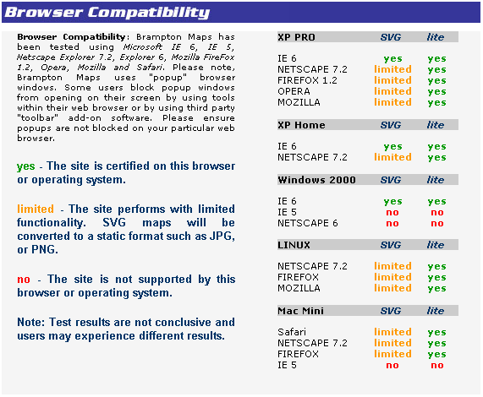
Part 1: Access Zoning Information

(i) On the City of Brampton’s Homepage, select Zoning By-Law under the Quick Links dropdown menu on the right.

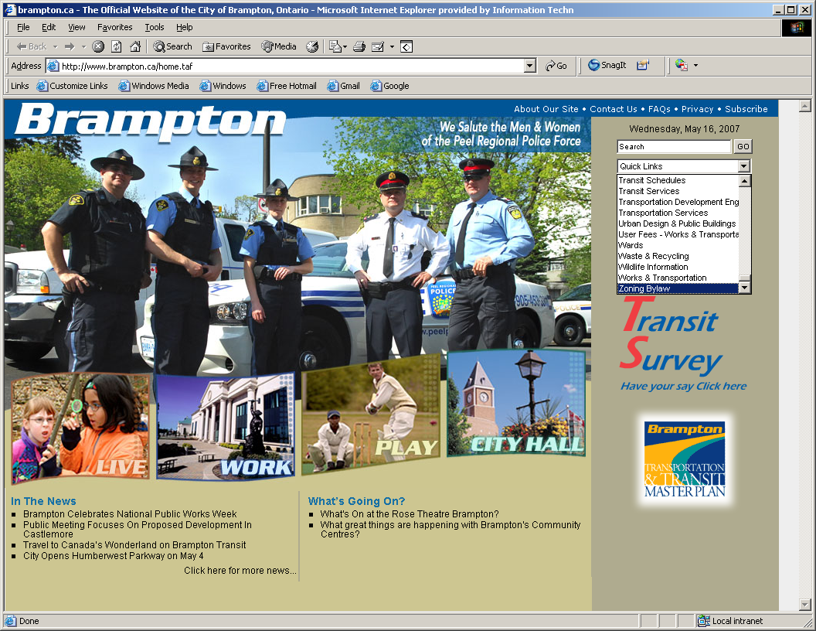

- Scroll to the bottom of the page and click “I Agree” after reviewing the disclaimer and it is agreed upon.

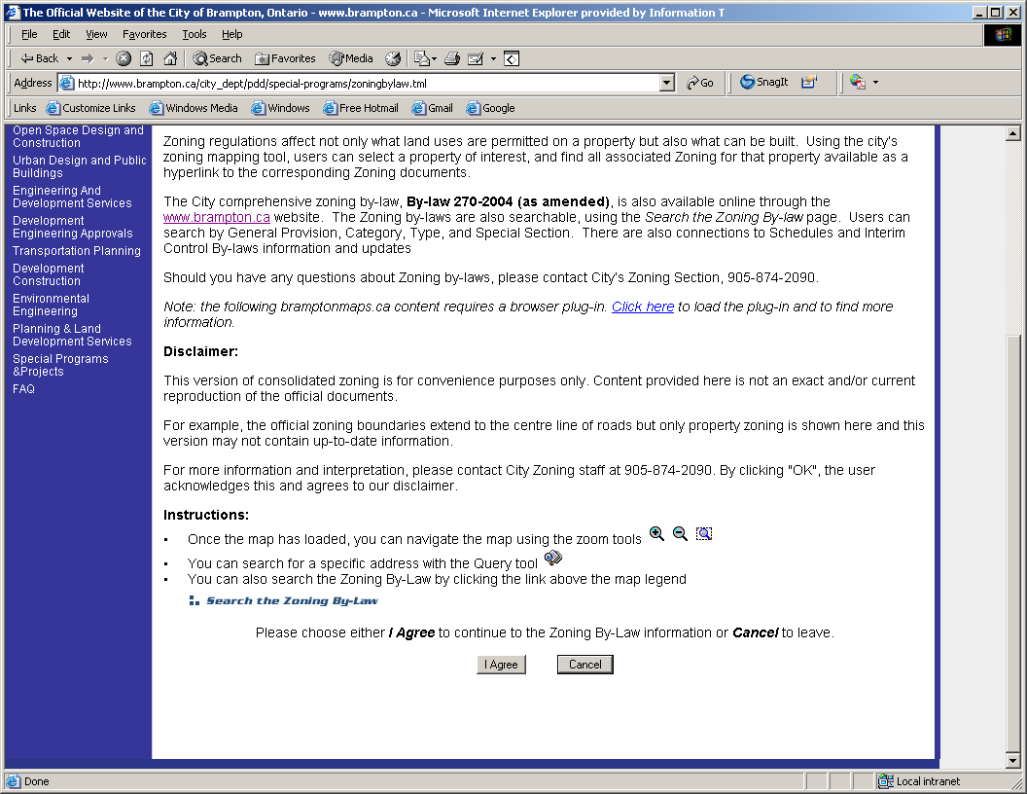
- Click on the “Maps” button to the left to access the maps. If you wish to search the Zoning by-law using text, click the “Search” button to the right.

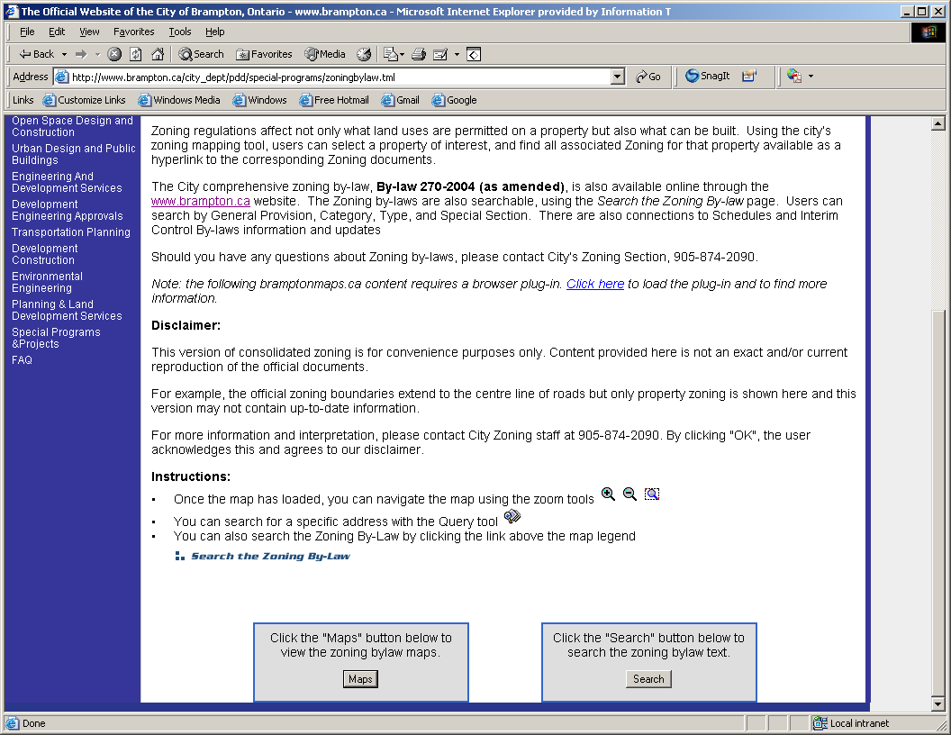

Part 2: Navigating and Using AIM

  - Start-up page

Tools – standard tools for navigating and searching the map

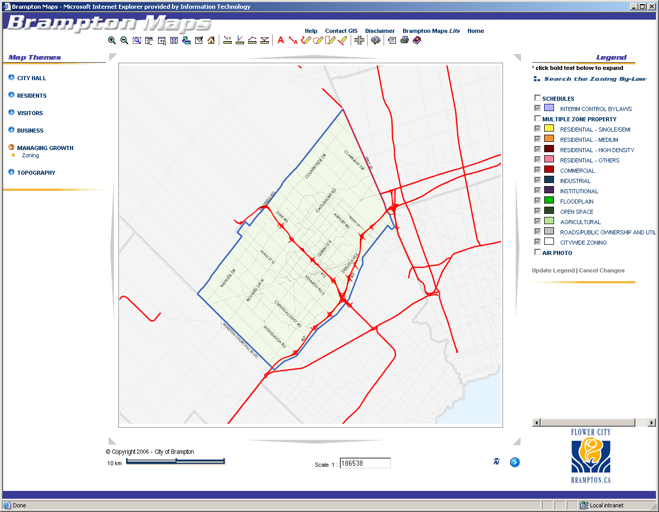

Scale and North Arrow

Legend – identifies what each colour represents
Types of Information Available – different information is available under different categories

  - Types of Information Available

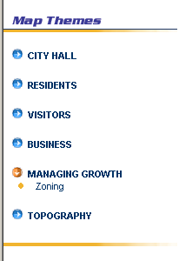
The left side lists all the different types of information available on AIM. Zoning information is located under “Managing Growth”.

Click on the various categories to display different information.

  - Legend

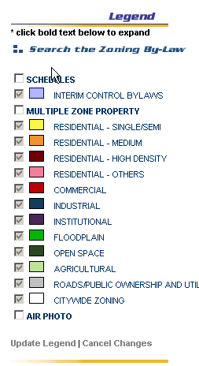
On the right, the legend indicates what the different coloured areas on the map represent.

Use the checkbox to trigger the information on or off when viewing.

The “Search the Zoning By-law” text is a link that will allow for searching of the zoning information without a need for knowing the property.

Please note that the Interim Control by-law layer may need to be unchecked in order to view certain properties; and the Multiple Zone layer may need to be triggered on in order to view different zoning within the same property.

2.3.1 Search the Zoning By-law

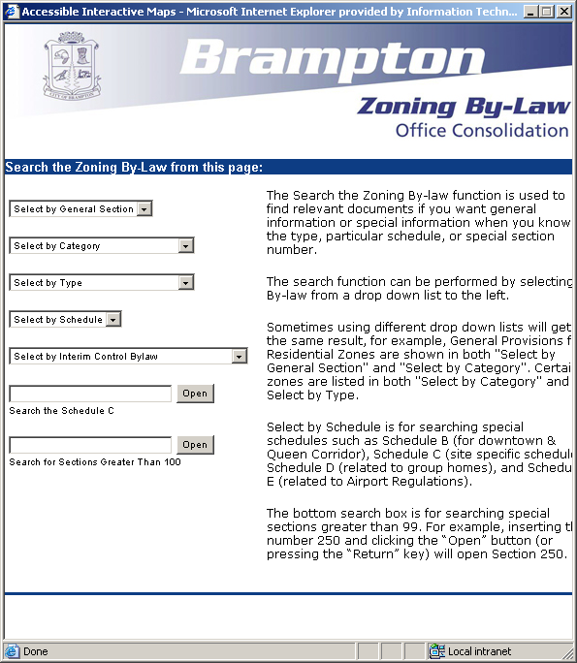
The Zoning By-law may be searched regardless of the property

  - Tools

Zoom in to a specific point
- click on the tool and click on the specific location on the map to zoom into the specified location
Zoom out of a specific point
- click on the tool and click on the specific location to zoom out of the specified location
Zoom into a specific area
- click on the tool, then click on one point on the map, drag the rectangular box over the area to zoom into the area without defining a specific point
Pan around the map
- click on the tool and click anywhere on the map; drag the line in the direction that you wish to move the map
Centre the map based on chosen point
- click on the tool and then the location you wish to have at the centre of the map
Return to the full extent of the map
- click to return the map to its original scale
Return map to previous scale
- click to return the map to the previously viewed extent
Refresh the map
- click to refresh the view of the map
Reload entire page
- click to refresh the entire web page
Display the Coordinates of a point
- click on the tool and then click on the location in question to show the coordinates
Bearing and Distance
- click on the tool and two different locations to find the bearing and distance
Measure the distance between two points
-click on the tool and two different locations on the map to measure the distance between them
Measure the total area
- click on the tool and the surrounding area of the property to measure its area
Write and insert text
- click on the tool and enter text in the box; click ok and click anywhere on the map to insert the text
Write and insert a label
- click on the tool and enter text; click ok and click anywhere on the map to insert the text with a leader line
Drawing tool – freehand drawing
- click on the tool and anywhere on the map to start drawing a line; single click to end the segment or double click to end the complete line
Drawing tool – circle
- click on the tool and anywhere on the map; move the cursor outwards to define the radius and click to place the circle
Drawing tool – rectangle
- click on the tool and anywhere on the map; move the cursor to draw the rectangle and click to end
Delete / Erase tool
- click on the tool and any of the text or objects drawn to delete it
Search for the intersection of two streets
- use the pop up dialogue box to find the intersection of two streets
Search for a property by using pre-defined queries such as address or PIN
- use the pop up dialogue box to find any property or location
Options (units and formats)
- allows the user to change the units and any of the formatting
Print
- click the print button to obtain print options, click preview; when the preview is displayed, print the page by navigating to File > Print
or Link to Help page
- click to retrieve the help manual
Email GIS
- for questions, comments or concerns, click here to email the GIS department
Disclaimer message
- click here to review the disclaimer message

- click here if you wish to view a basic version of Brampton Maps
- click here to return to Brampton Maps homepage

2.5 Scale, North Arrow, Miscellaneous - Others

Please note that the zoning information will not be viewable unless the map is at a larger scale than 1:10000.

Hint: The check boxes on the legend will be greyed out until the map is at a suitable scale for the information to be displayed.

The scale may be changed using the zoom-in and zoom-out tools or by typing in the scale number into the scale box.
Scale Bar

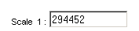Scale

North Arrow
- this shows the direction of the map
Hide or Show Legend
- this button will allow for the legend to be hidden or shown; by hiding the legend, the map window will be larger

Part 3: Locating Properties

3.1 Searching for the Property
    - Pre-defined Queries

- Use the “pre-defined queries” button to locate specific properties by its address.

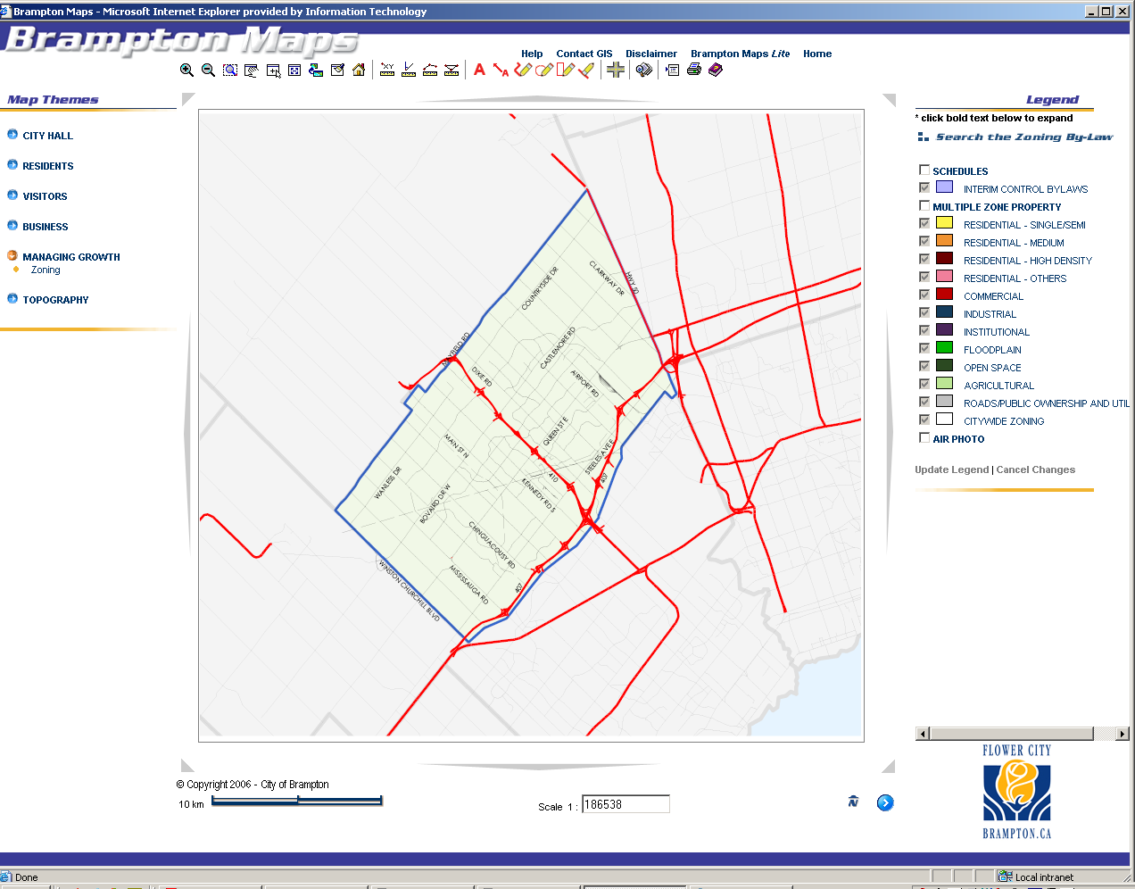

- Another window will pop up with the search parameters. Enter the address and other details you wish to search by.

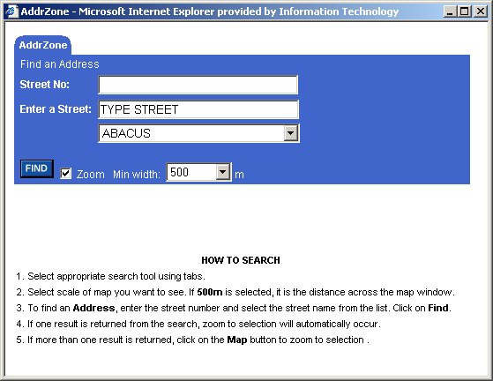
Click here after entering required information to find property
Select map scale (to zoom in closer to the property, select a smaller number)
Instructions for how to search using each tool are below for guidance
- The map will automatically zoom into the property that is found.

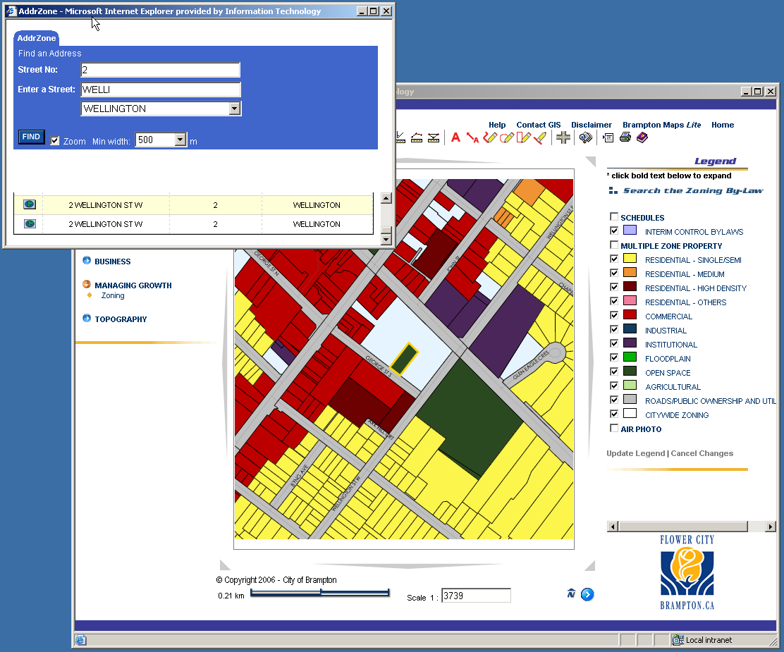

Note: If the property falls under the “Multiple Zone Property” feature, you will need to refresh the map before you are able to view the information available regarding that property.

3.1.2 “Find Intersection of Two Streets”

(i) The “find intersections of two streets” tool can also be used to find a property if the exact address is unknown.

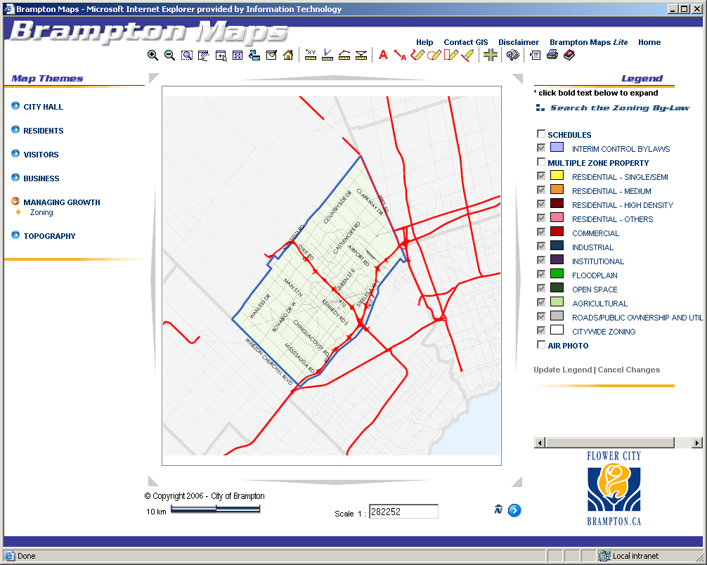

- Another window will pop up with the search parameters.
Find and select the name of the first street of the major intersection

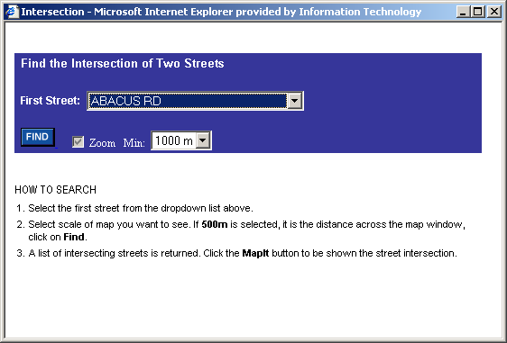
Click the find button to load streets that intersect with the first street
Set the scale of the map
Instructions for how to search are available for guidance
- All the streets that intersect with the first street given will be displayed. Click on the icon on the left of the street you would like the first street to intersect

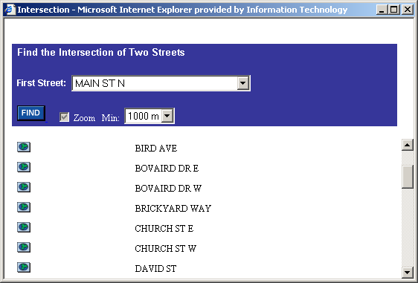

- The map will zoom to the specified intersection

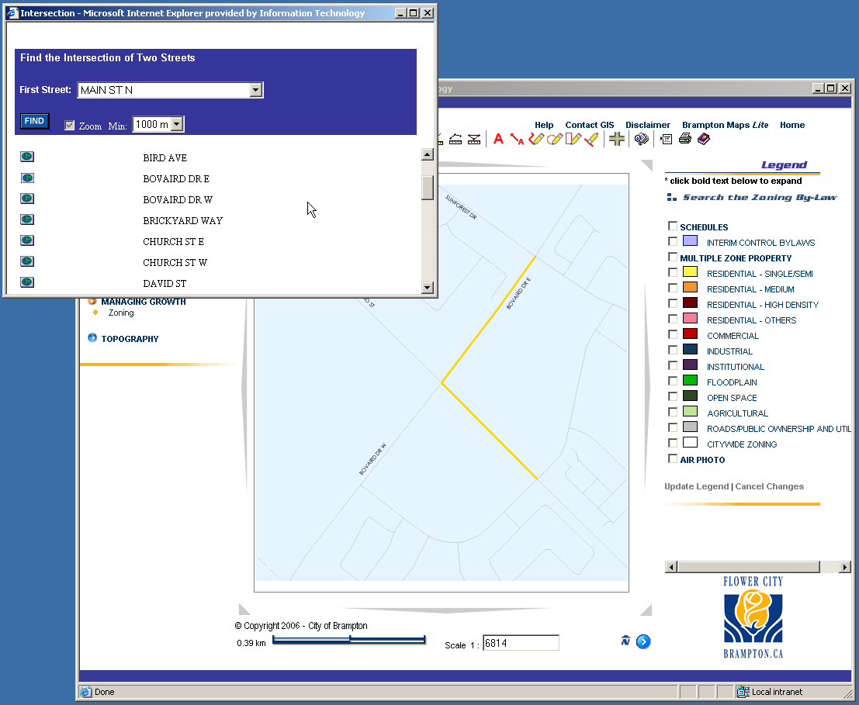

3.2 Viewing the Zoning Information

- Click on the property once it has been found

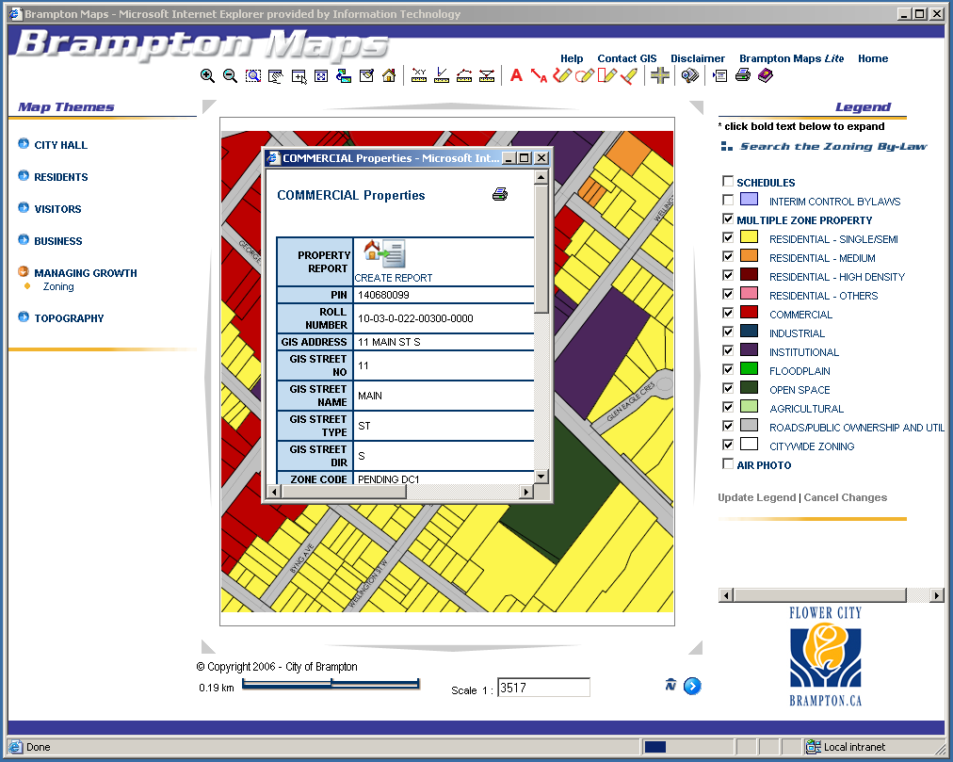

- A pop up window with all available information for the property will open

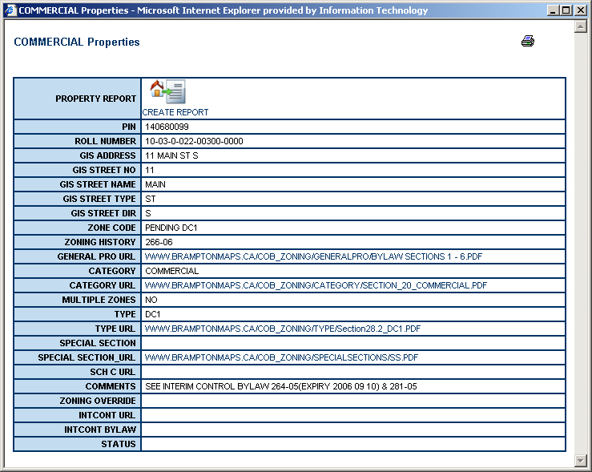

- Click on the URL links provided for further detail
    - Property Report 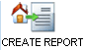

- To view the Property Report, click on the “Create Report” icon. A pop up window containing various reports will be available. The Zoning report is the last available tab. Click on “Zoning”.

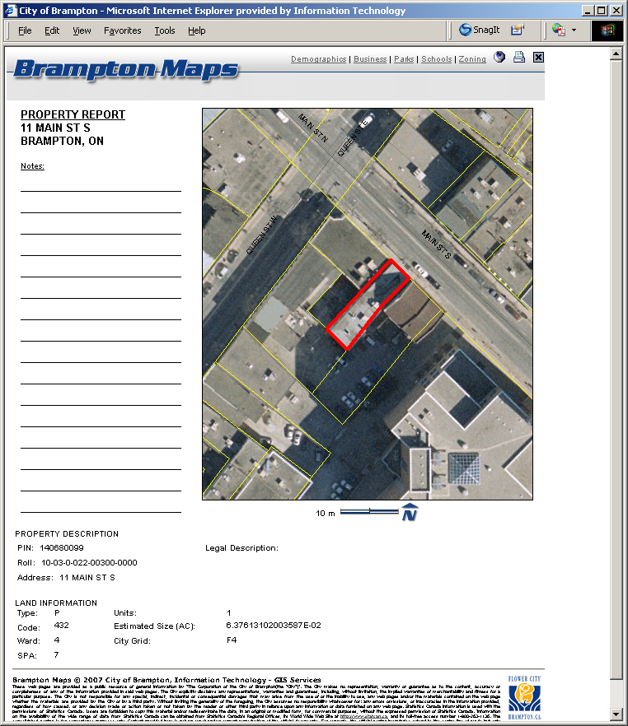

- A disclaimer will pop up on the screen. Review the disclaimer and if agreed upon the terms, click OK.

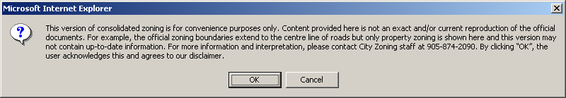

- The Zoning Report will then be displayed.

Other reports that are available
Close Window
General Information and Legend
Print Button

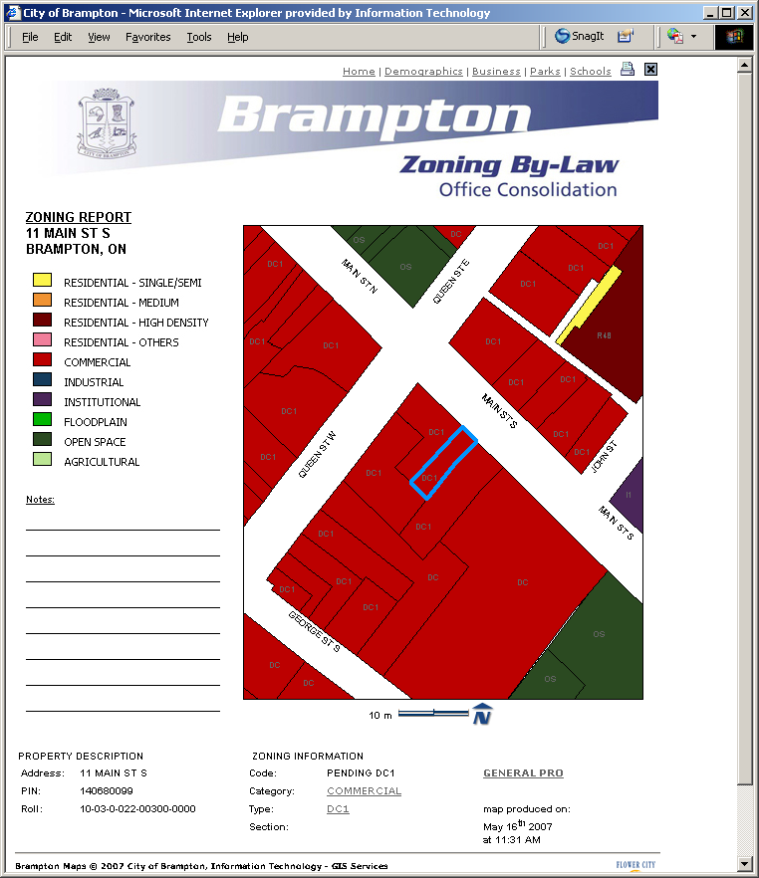
Map
General Description regarding the property
Zoning Information for the property.

Please note that the underlined text is a link to the detailed text for the category, type and section.
Date and Time report is generated.
Scale and North Arrow
General Provisions - link

